**Unit 4 - Activity 7**

**Millikan’s Oil Drop Practicum**

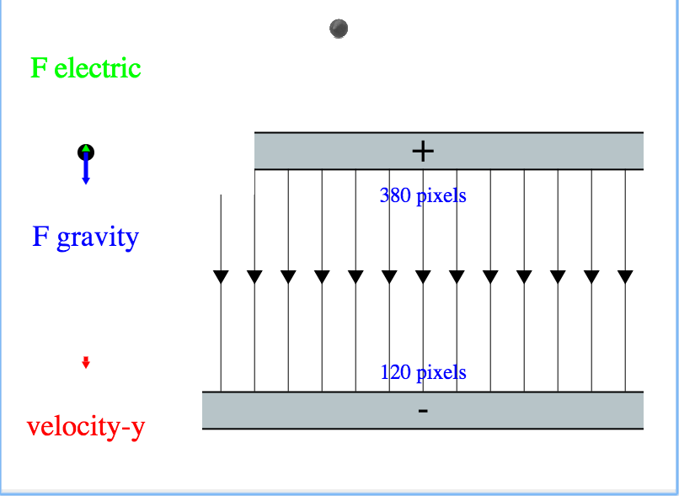

In this scenario, an oil drop with an electric charge falls into an area with a uniform electric field. Your goal is to determine the magnitude of electric force that must be present on the given oil drop, so that it moves through the electric field at a constant velocity. Outside the electric field the oil drop is in falling without air resistance.

Robert Millikan did not know how strong he needed the electric field to be, nor will you.

The charge will be falling with a zero initial velocity and constant acceleration due to Earth’s gravitational field. Once it passes into the uniform electric field of unknown strength it will also experience a force due to the electric field. The charge of the oil drop (q) is 2 𝛍C. (Recall, 𝛍is the symbol for ‘micro’ and means 10-6.)

Once you have determined the magnitude of the electric force, use your understanding of the gravitational force near Earth to determine the mass of the oil drop.

[**https://goo.gl/Dghuoq**](https://goo.gl/Dghuoq)

Sample student code:

|  |
| --- |
| e-field = ...  **fun** F-ELEC(y, charge)**:**  **if** ...**:**  ...  **else if** ... **:**  ...  **else:**  ...  **end**  **end** |

Questions:

1. What type of feedback did you get to help you successfully move the oil drop through the electric field at a constant velocity?

2. How did you determine the strength of the electric field required for constant velocity? (BE SPECIFIC)

3. How did you determine the mass of the oil drop?